ITUE203: WEB DEVELOPMENT FRAMEWORKS 25CS106– Yana


Faculty of Technology and Engineering

Chandubhai S. Patel Institute of Technology (CSPIT) Department of Computer Science & Engineering

Laboratory manual
Academic Year | : | 2026-27 | Semester | : | 3rd

Practical - 07

PROBLEM STATEMENT :
Process submitted registration/contact form data using PHP. Validate and sanitize inputs on the server side and store records in CSV or JSON file format. Display success/error messages.
OBJECTIVE:
To develop a PHP-based web application that processes registration or contact form submissions using the POST method, validates and sanitizes user inputs on the server side, and safely stores the submitted data in CSV or JSON format. The application also displays appropriate success and error messages based on the form submission results.
OUTPUT:

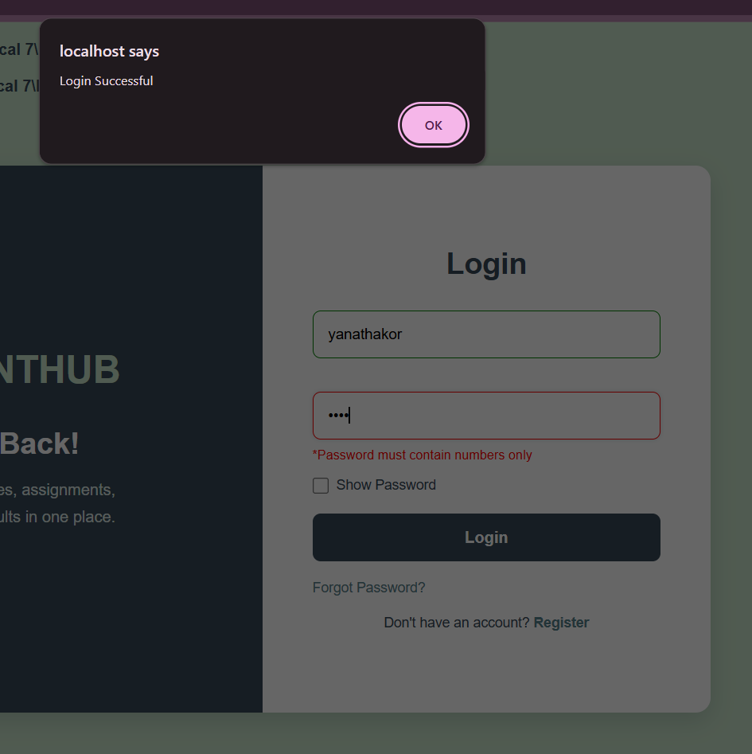
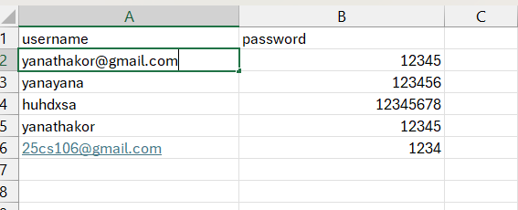

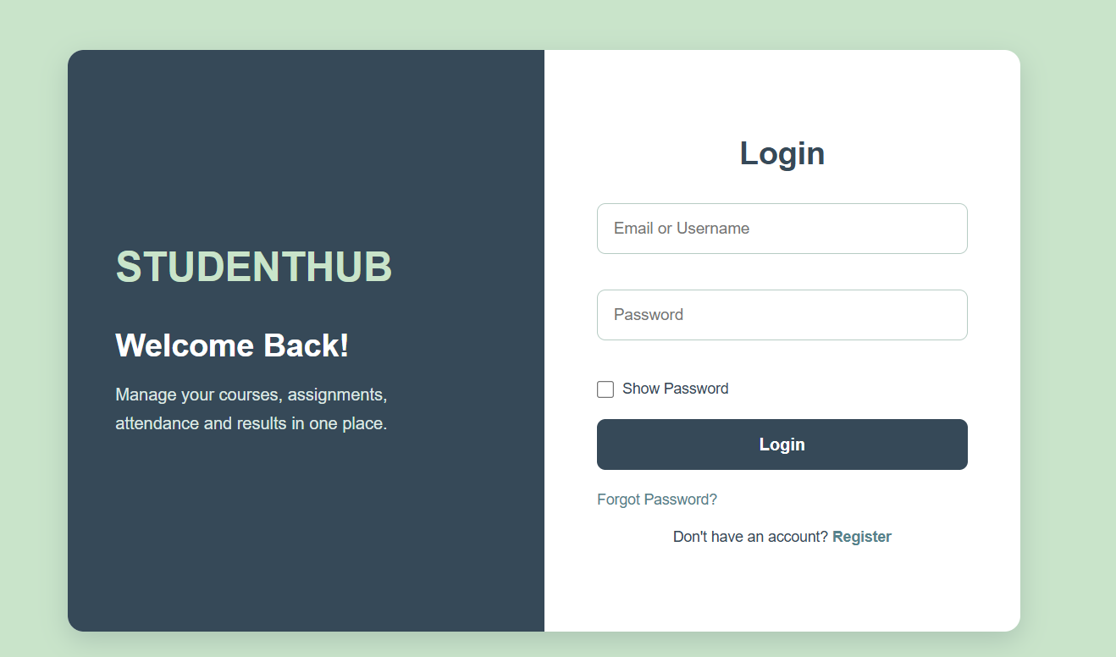

LEARNING OUTCOME:
Students will be able to implement server-side form processing using PHP, validate and sanitize user inputs, handle POST requests, and store submitted data safely in CSV or JSON files. They will also learn to display appropriate success and error messages and develop basic backend applications for collecting and managing user data.

